**Proposed topic:**

**E-commerce website for handmade gifts named as: handy_treasures**

**Name : Neha kapoor**

**PTU Roll no: 020117003**

**Class roll no. : :3**

**Email id:** [*Nehakapoor1901@gmail.com*](mailto:Nehakapoor1901@gmail.com)

**Contact number : 9873848098**

**Branch: Computer science**

**Batch: 2017-2021**

**Index**

|  |  |
| --- | --- |
| **S.No.** | **CONTENT** |
| **1.** | Introduction |
| **2.** | Feasibility study |
| **3.** | Methodology |
|  | Facilities required   * + - Software requirments     - Hardware requirments |
| **4.** | Biblogrpahy |

**INTRODUCTION**

Electronic Commerce or e-commerce is business transactions that take place by communication networks. It is a process of buying and selling products, services, and information over the computer network. E-commerce is a set of dynamic technologies, applications and business process that link organizations, customers, suppliers, and communities through electronic transactions and the electronic exchange of information products and services. Electronic commerce that is conducted between businesses and consumers, on the other hand, is referred to as business-to-consumer or B2C. This is the type of electronic commerce conducted by companies such as Amazon.com. In this project we will make a website of handmade gifts named as handy_treasures. It is an e-commerce website which helps to choose a wide range of products through your desktop or smartphone rather than visiting the outlet or social media pages. It is developed using python and framwork Django which is an open source blogging platform and content management, It is been developed to handle accurate stock and also to overcome a payment gateway problem. Handy_treasures ensures that it accepts a review from our genuine buyers.

The Modules used in the project are

1. Admin  
2. Customer

**Admin:**

Admin will login into the application with the default username and password. Admin can add and edit the products and product details. He can also view the orders placed by customers and reviews by customers. Admin can also view the abandoned cart products and featured products. Admin can also view the payments.

**Customer:**

The customer can view the application by registering or without registering as a guest user. But the guest user has limited functionalities compared to the registered user. Registered customer must log in with the username and password after logging in he can select the products and add them to the cart. After the product is selected customer needs to provide some additional details like shipping address after that the payment will be initiated by the customer, after successful payment the customers will get 3 emails listed as Order copy, Delivery Details Copy and Thanks Copy.

**FEASIBILTY STUDY**

1. To provide information about various products in a different category.
2. Customer can purchase Products Online.
3. Customer can log in and get various information about products and can purchase a suitable product with price and quality comparison.
4. Customer can pay online, so security is must, therefore, e-shopping provide secure transactions.
5. After-sale e-shopping also provide after-sales service in which customer problem is solved.
6. Data security is maintained to a relatively high level by implementing it at the Database level, so as to ensure that only authorized users have access to confidential client information

**Methodology/Planning of work**

Use case Diagram for Admin:

[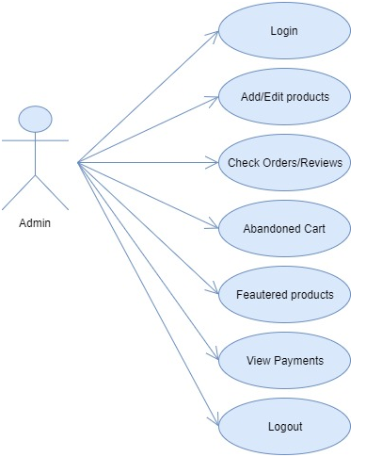](https://secureservercdn.net/160.153.137.210/11v.681.myftpupload.com/wp-content/uploads/2018/10/E-Kart-Website-Use-Case-Diagram-for-Admin.png)

Use case Diagram for Customer: [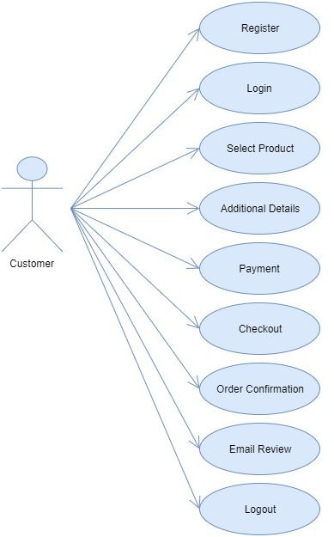](https://secureservercdn.net/160.153.137.210/11v.681.myftpupload.com/wp-content/uploads/2018/10/E-Kart-Website-Use-Case-Diagram-for-Customer.png)

**FACALITIES REQUIRED FOR PROPOSED WORK**

**SOFTWARE REQUIRMENTS:**

* Opearting system : Microsoft windows 10.
* Front end : Atom
* Language : HTML, CSS, Bootstrap, Javascript, Python.
* Web browser : Google chrome
* Framework : Django

**HARDWARE REQUIRMENTS:**

* 1.6 GHz or faster processor
* 2 GB of RAM
* 10 GB of hard disk space for a typical installation
* 600 MB of available hard disk space (language pack)
* 5400 RPM hard driveDirectX-9 capable video card running at 1024 X 768 or higher display resolution

**BIBLOGRAPHY**

* [**www.google.com**](http://www.google.com)
* [**www.youtube.com**](http://www.youtube.com)
* [**www.indiaBix.com**](http://www.indiaBix.com)
* [**www.codeproject.com**](http://www.codeproject.com)
* [**www.ecommerce-blog.org**](http://www.ecommerce-blog.org)
* [**www.webopedia.com/DidYouKnow/Internet/2007//Affilate_Marketing.asp**](http://www.webopedia.com/DidYouKnow/Internet/2007//Affilate_Marketing.asp)